TECHNOCRATS ROBOTICS

SUMMER TASK – 3



TASK 3 – BASIC MODULES

BY – RUDRA PATIL

LINE SENSORS LSA08

The LSA08 is an advanced sensor bar used for line following. It consists of a total of 8 IR sensors on the boundary of the sensor. It is used for doing line following tasks for robots. The very important feature of LSA08 sensor is the ability to operate on a surface of various colors like red, green, blue etc.

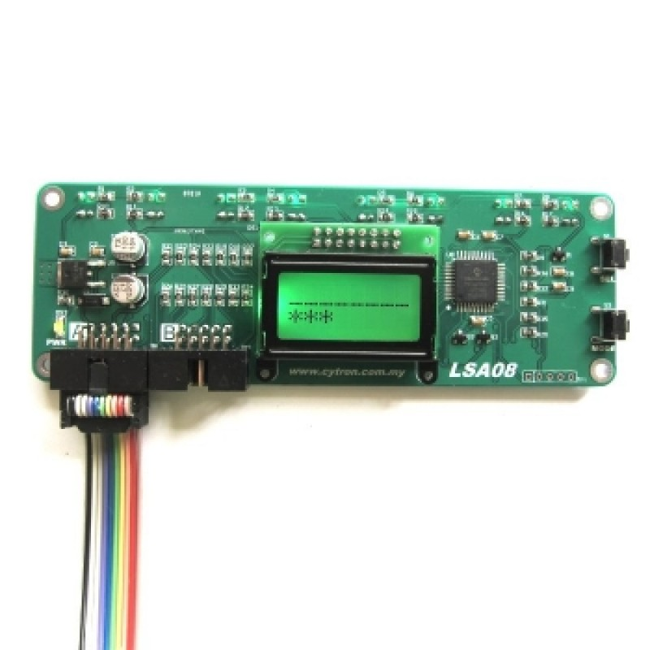

Why is LSA08 used over typical IR sensor?

1. LSA08 has a LCD Display which displays the line information and sensors.
2. It has 8 sensors in total placed 16mm apart which provides greater accuracy.
3. Low current consumption
4. Applying reverse voltage will not damage the sensor.
5. The sensors on the LSA08 can even detect the line on a reflective or glossy surface.

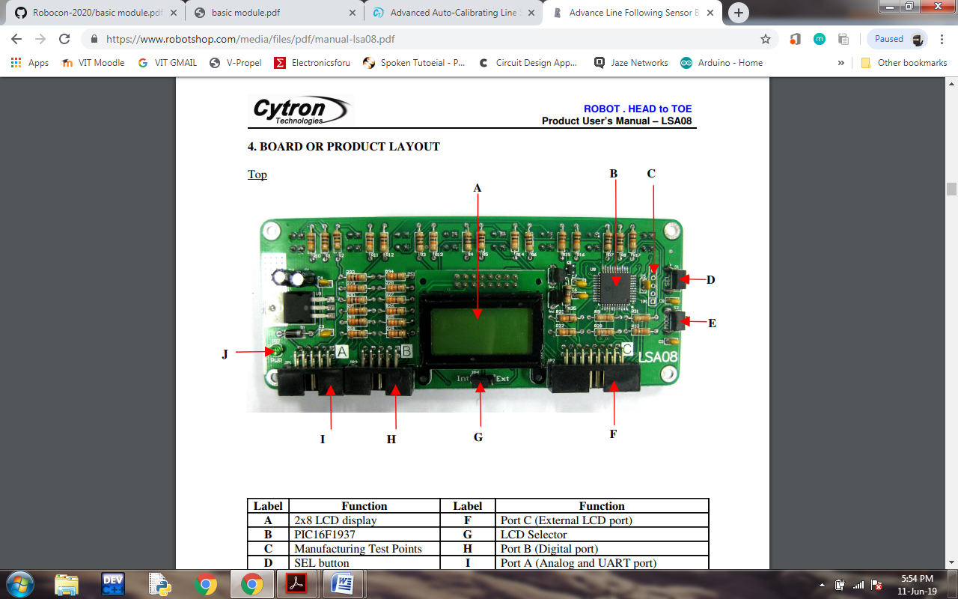

The components:

A – LCD Display.

B – Processing Unit.

D – Button used to enter into a selected mode.

E – Used to select a particular setting

F – UART and analog Port.

G – Digital Parallel output Port.

H – Power indicating LED.

Various Modes on a LSA08 Sensor

1. Calibration Mode – Calibrate the sensor according to the line and background.
2. Line Mode – We use a dark mode for dark line and bright background and light mode for bright line and dark background.
3. LCD Contrast – Sets up the contrast for the LCD Display.
4. Offset Mode – It is used to setup minimum and maximum values to be received by the IR sensor so that it can eliminate fluctuations.
5. UART address – Unique UART address for LSA08
6. UART Baud rate – Sets up the baus rate for the UART Communication
7. LCD Backlight Mode
8. Exit

LSA08 has three working modes which we can connect like UART mode, DIGITAL mode and the ANALOG mode.

In Analog Mode, the analog output pin is connected to the to the analog pin of the microcontroller. The Vin and GND of the LSA08 is connected to the Vin and GND of microcontroller.

In Digital Mode, the pins of the LSA08 are connected to the 8 digital pins of the micro controller and the Vin and GND of the LSA08 to the the Vin and GND of the microcontroller.

PIXY CAMERA

Pixy camera is an image sensor and provides vision for the computer. It is used to find objects in very less time. We have to teach the pixy cam to do the detection tasks. It has a powerful processor and has a easy interface with micro controllers like Arduino. We can attach many pixy camera to a micro controller. It uses the RGB colour detection technique and can also detect hue and saturation of the image. It has a processing speed of 50 frames per second for detection of objects. It is also a low cost alternative. It can communicate using SPI, I2C and serial communication protocols.

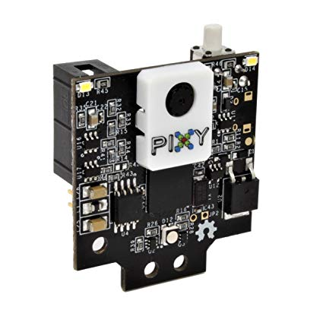

PINOUT DIAGRAM OF PIXY CAMERA

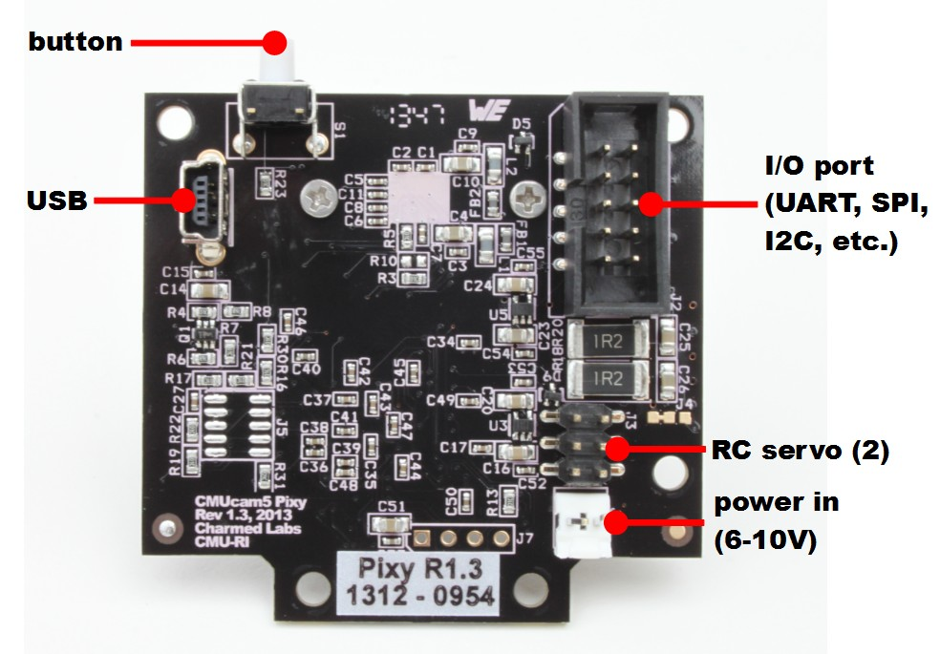

CONNECTING PIXY CAM TO ARDUINO

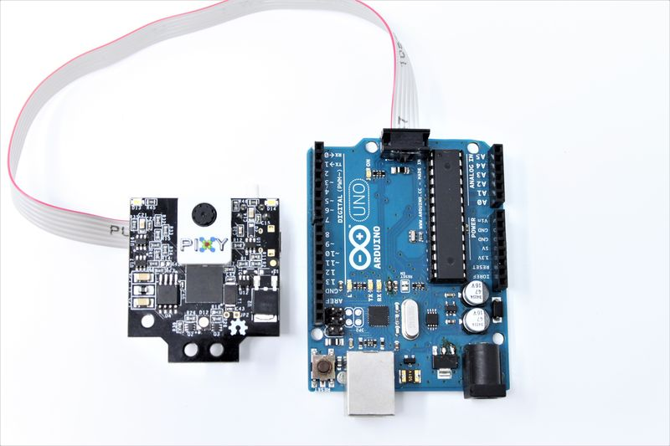

You can directly connect the pixy and arduino using this special cable meant for this purpose.

16 CHANNEL PCS9685

The PCA9685 is a servo motor driver which has 16 channels and is controlled by I2C communication. This board can drive upto 16 motors at a single time and uses only 2 pins for connection to the micro controller. There are 16 PWM controllers already on board which do not require additional processing from Arduino.

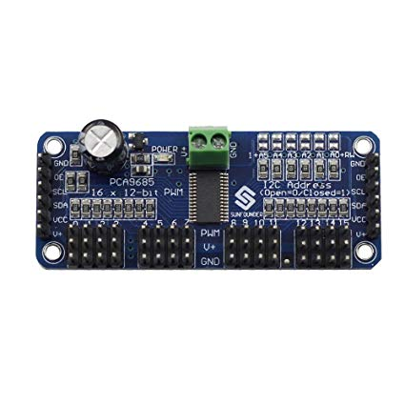

The 16 ports, each have 3 subports namely GND, PWM output and the Vin ports. It can run at a frequency of 24Hz to 1526 Hz with a duty cycle which we can adjust from 0 to 100.

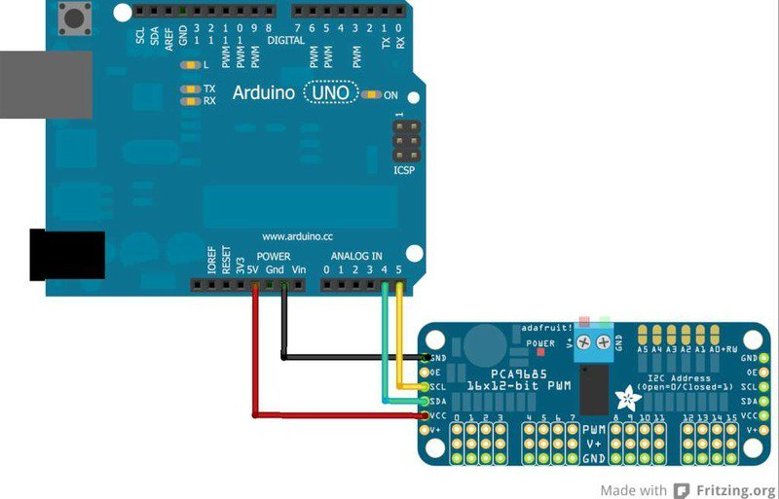

1. The Vcc of the module is connected to the 5V Arduino pin
2. GND is connected to the GND of Arduino.
3. SDA and SCA port to any of the analog pins.
4. The three pin connectors are used for connecting the servo. These connectors are connected to external 5V ports to supply power to the servo.

CITRON SC16A

SC16 module can control 16 independent servo motors simultaneously on a single board. It can generate servo pulse for 0.5ms to 2.5ms which allows the servo motor to rotate upto 180 degrees. We can connect 2 such SC16A boards so we can control close to 32 motors. The SC16A can be powered by USB Port and micro controller with UART Interface.

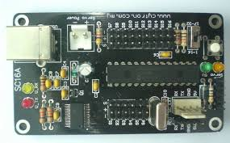

Features:

1. 16 Channels for independent control.
2. Can handle maximum of 32 servos.
3. We can choose the ramp rate (speed) of the motors.
4. User can control motors using GUI software on a laptop.

PIN LAYOUT DIAGRAM

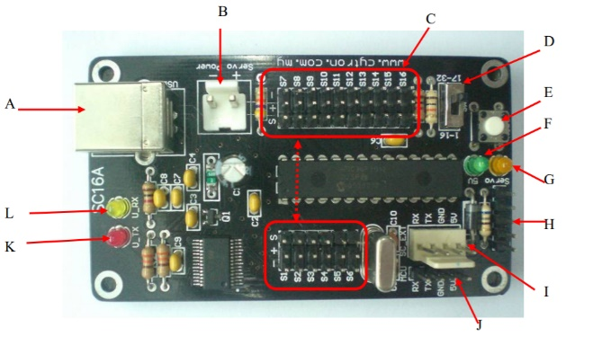

A – USB Connection

B – Connector to servo motor power source

C – 16 motor ports

E – Reset Button

F – Power indicating LED power to SC16A Cytron.

G – LED to indicate power to servo motor.

I – 4 pin connection for an extension board pin.

J – 4 pin header pin to control power and signal wire from microcontroller

When connecting an Arduino we connect the RX of Cytron to the RX of arduino and similarly with TX.

CYTRON MDDS10 MOTOR DRIVER

It is the a motor driver designed to drive two medium powered brushed DC motors which have a capacity up to 10A continuously and 30A at peak for a few seconds. It is a dual channel setup meaning it can control 2 motors either simultaneously or independently. It has a reset button to stop operation in a quick way. It has a power and error indicator along with RUN LED’s. The driver has no polarity protection we must always check the polarity of the motor driver before turning on the connections. It has an onboard temperature sensor which limits the output current in order to prevent itself from overheating.

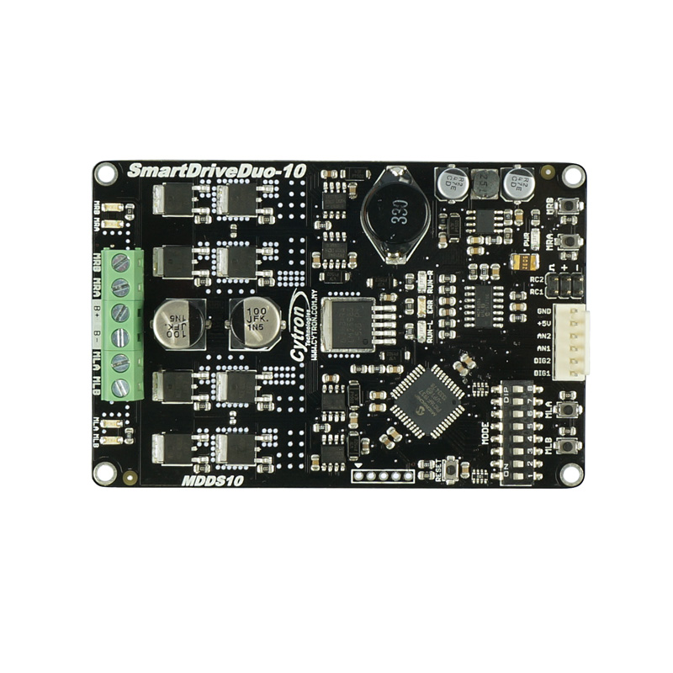

It is designed to control the drive modes in a normal RC car. It has Multiple input modes: RC, Analog, PWM, Simplified Serial and Packetized Serial.

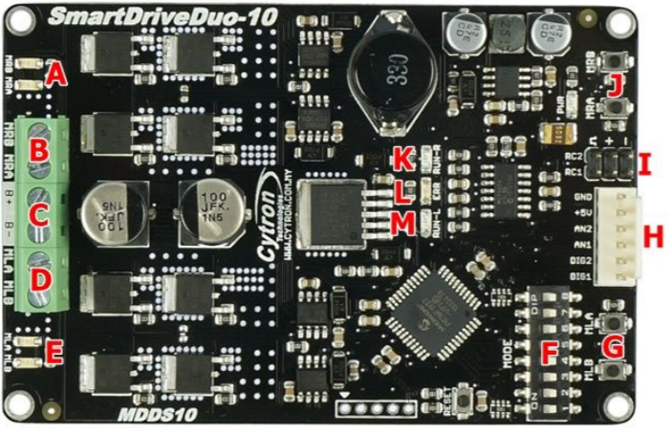CONNECTIONS TO THE MODULE

A – Right motor LED  
B – Right motor terminal (2)

C – Power supply terminal(2)

D – Left motor terminals(2)

E – Left motor LED

F – Mode selection switch

G – Left motor test switch

H – Analog/PWM/Digital/Serial Pin

I – RC input pin

J – Right motor Test

L – Error LED

CONNECTIONS TO ARDUINO

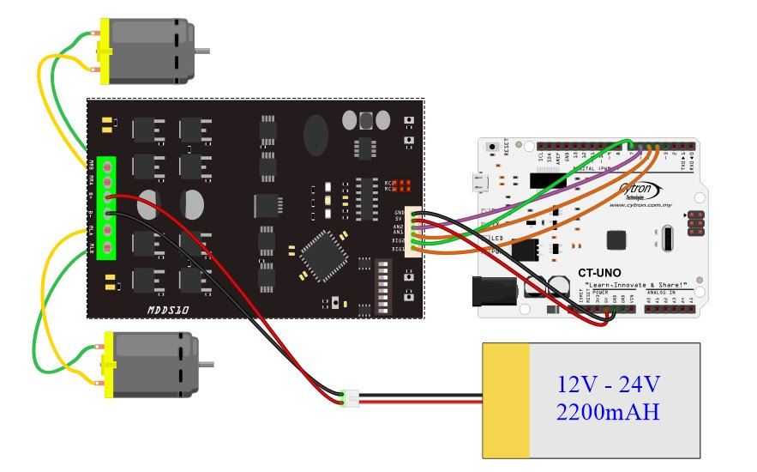

We connect the power supply to the battery. The terminals of the motor are connected to the respective terminals in the citron module. Connect 5V and ground respectively to the 5V and ground of the Arduino. Connect the digital pins to digital pins of arduino and analog pins to the PWM pins of the Arduino.